
press release
(English translation)

RECOVERY FROM MIR 2023
FOR THE ENTERTAINMENT AND SHOW INDUSTRY

- Data confirms that already in 2022 some sectors exceed the pre-pandemic revenues of 2019
- Concerts and live music increasingly driving
- Appointment at the Rimini Expo Centre of Italian Exhibition Group from April 2nd to 4th

www.mirtechexpo.com
Rimini, 29 March 2023 – The entertainment and shows industry returns to see the light. This is confirmed by the data collected in view of the sixth edition of MIR, the only event in Italy dedicated to audio, video, control and lighting technologies for concerts, shows, education, retail, museums and hospitality, which allows you to test the new products live of leading companies in the sector. Organized by the Italian Exhibition Group (IEG), the event will be held at the Rimini Expo Centre from April 2nd to 4th.
MIR comes after difficult years, not only from an epidemiological point of view, but also from an entrepreneurial point of view linked to the entertainment sector. This sector has been among the most penalized by the Covid restrictions, even if it is trying to return to its traditional economic volumes. A goal not yet fully achieved, but the most recent data confirm the recovery. According to the SIAE surveys, from January to September 2022 the total number of "shows" was equal to 24,119, with approximately 13 million "admissions", while the expenditure at the box office totaled the figure of almost 451 million euros, with an average ticket price of 35 euros. Also thanks to a rather rich calendar and the recovery of numerous shows postponed due to the restrictions.
An interesting indication especially considering that there was also an increase compared to 2019, when there were 12.3 million admissions for a cost of 369 million euros, with an average ticket price of 30 euros. So in 2022, compared to 2019, against a 19% decrease in the number of shows, there was a 6% increase in spectators and a 22% increase in box office spending.
The prospect of a recovery also involves the discos and dance clubs sector, heavily affected by the restrictions imposed by the pandemic, which has only returned to normal operations since mid-2022, with the end of the limitations on activities and the state of emergency. According to Fipe-Silb, the turnover of the sector is in any case over 720 million euros, but the total turnover including related industries (music industry, sound and light, food, etc.) reaches 2 billion (in 2019).

The direct employees are estimated to be at around 50 thousand, with an average of around 18 employees per disco, 11 of whom are employees with an employment contract. In any case, the incidence of seasonal contracts is high and equal to 63.8%.

The desire to go back to having fun, to go to concerts, to sit in an armchair in theaters and to take to the dance floor was highly predictable and the trend is also confirmed by the elaborations of the Banca Ifis Research Department. According to the institute's analysis, the show and entertainment economy in 2022 generated a volume of over 54 billion euros (1.5% of the national GDP), exceeding the total pre-pandemic revenues (2019) with a flattering +2%.
However, Banca Ifis' research points out, despite the recovery of live shows and the growth of core activities, in 2022 the activities functional to the creation and dissemination of artistic performances and entertainment are still slightly lower (-2%) than 2019 levels A gap that will predictably be reabsorbed this year.
For 2023, it is estimated that growth will strengthen (+3%), reaching almost €56 billion in revenues. The sectors with the greatest development will be those most closely linked to the creation of content (+6%, equal to +778 million € of revenues) and media (+3%, equal to +852 million € of revenues) of entertainment and entertainment, especially television and cinema.
MIR 2023 AT A GLANCE
Organisation: Italian Exhibition Group SpA; Recurrence: annual; Edition: 6th; Open to: professional operators and general public; website: www.mirtechexpo.com

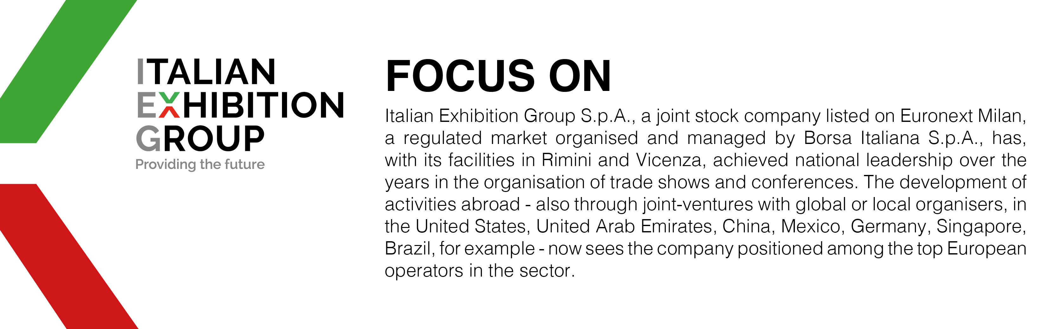

PRESS CONTACT ITALIAN EXHIBITION GROUP
Head of media relations & corporate communication: Elisabetta Vitali
Press office manager: Marco Forcellini
International press office coordinator: Silvia Giorgi

MEDIA AGENCY MIR
Naper Multimedia| Zoe Perna | T. +39 02 97699600 | email: staff@napermultimedia.it

This press release contains forecast elements and estimates that reflect the management’s current opinions (“forward-looking statements”), particularly regarding future management performance, realization of investments, cash flow trends and the evolution of the financial structure. For their very nature, forward-looking statements have a component of risk and uncertainty, as they depend on the occurrence of future events. The effective results may differ (even significantly) from those announced, due to numerous factors, including, only by way of example: food service market and tourist flow trends in Italy, gold and jewellery market trends, green economy market trends; the evolution of raw material prices; general macroeconomic conditions; geopolitical factors and evolutions in the legislative framework. Moreover, the information contained in this release does not claim to be complete, and has not been verified by independent third parties. Forecasts, estimates and objectives contained herein are based on the information available to the Company as at the date of this release.

